GITHUB
NAME: VIDULA R COURSE CODE: CSA1013
REG NO : 192511270 COURSE NAME: SOFTWARE ENGINEERING
EXP:01- Collaborative Software Development Using Git and GitHub Through Fork-and-Pull Request Workflow

Aim
To demonstrate collaborative software development using Git and GitHub through the Fork-and-Pull Request workflow.

Pull Request merged successfully into the main branch.

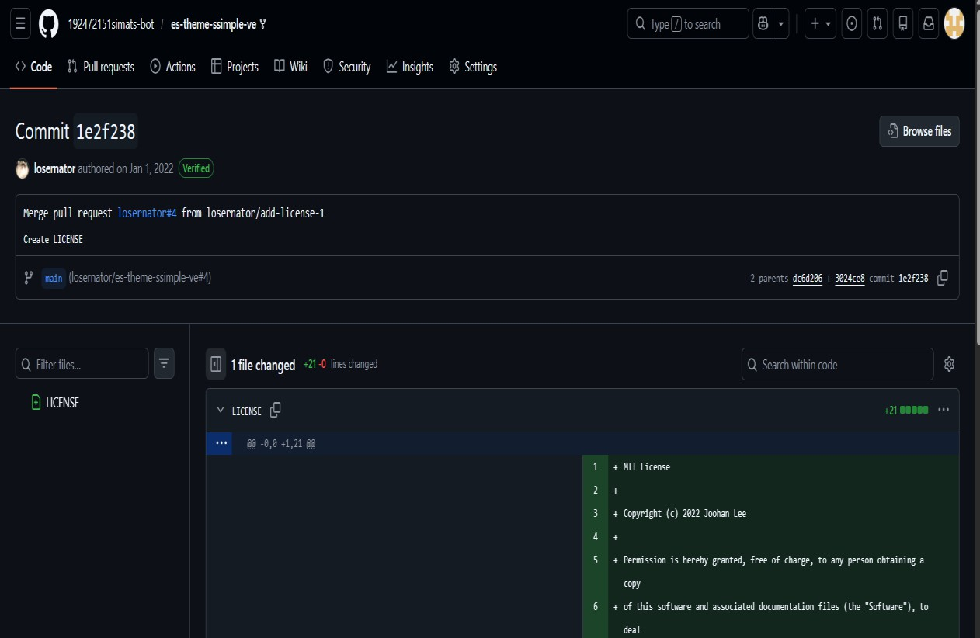

RESULT

Successfully forked and cloned a GitHub repository, created a feature branch, made and committed changes, pushed the branch to GitHub, created a Pull Request, reviewed the changes, responded to feedback with additional commits, and merged the approved changes into the main branch.

Project Aim
To demonstrate how to create Git branches, collaborate with others, merge changes, and resolve merge conflicts using Git and GitHub.

GitHub commit showing a link change from Gitter to Discord.

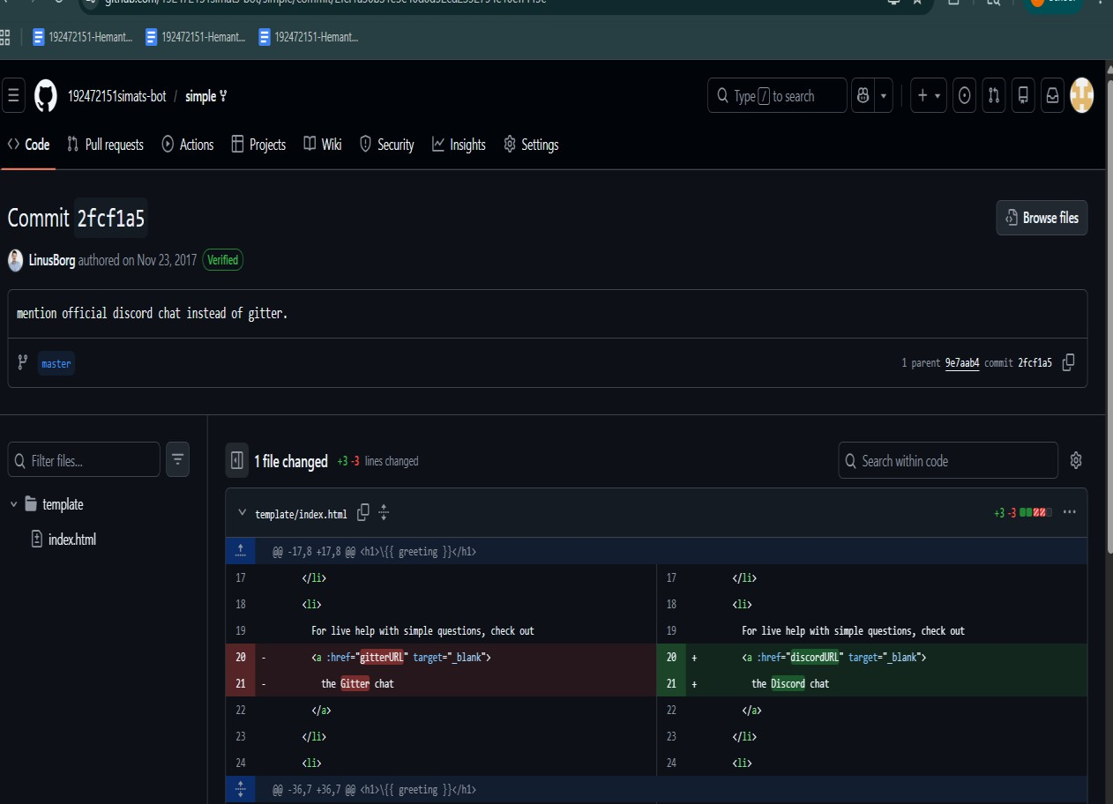

Result
Successfully created and worked on a Git branch, merged the latest changes from main, resolved merge conflicts, committed the resolution, pushed the updated branch, and created a Pull Request.

Aim
To create and manage a GitHub repository for a team project using branches, pull requests, code reviews, and conflict resolution.

Git branches created and pushed successfully.

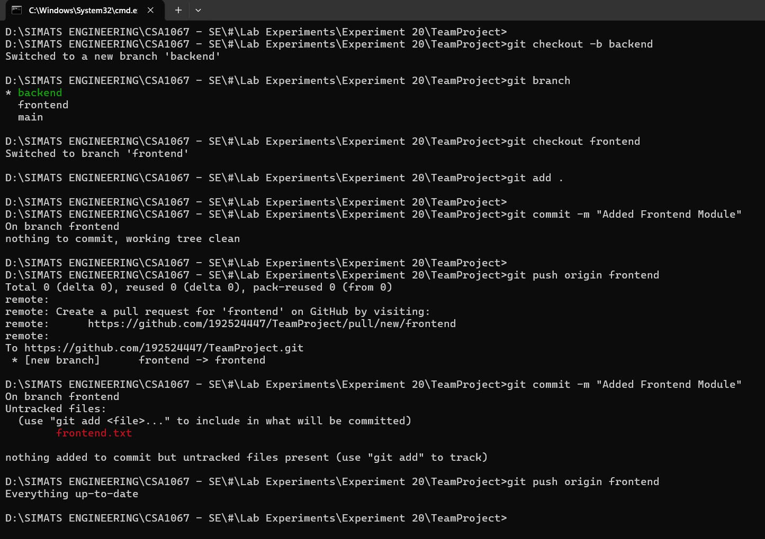

Result
Successfully created a GitHub repository, implemented module-wise branches, merged changes through Pull Requests and code reviews, resolved merge conflicts, and documented the version-control workflow in the README file.

Aim
To automate the testing, Docker image building, publishing, and deployment of a containerized Flask application using GitHub Actions.

CI/CD pipeline completed successfully.

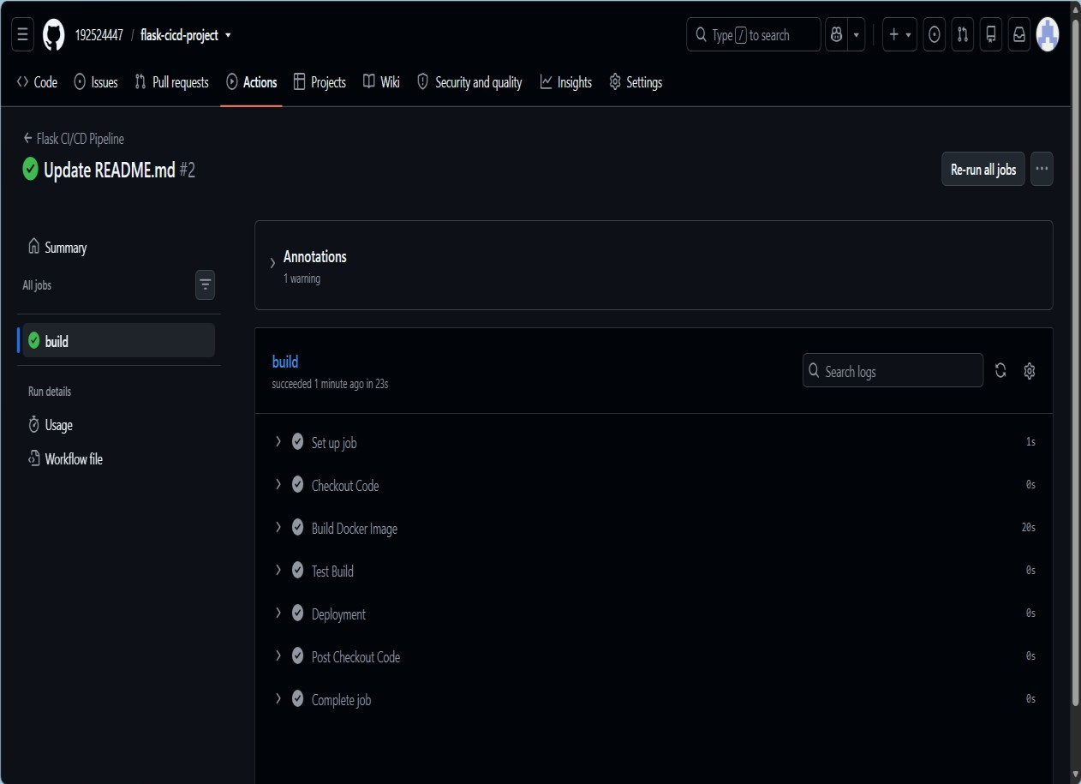

Result
Successfully created a CI/CD pipeline for a containerized Flask application using GitHub Actions, automated testing and Docker image creation, pushed the image to Docker Hub, and deployed the application to a cloud platform.

Aim
To create a GitHub repository, clone it locally, modify the README.md file, and push the changes back to GitHub.

README updated and committed successfully

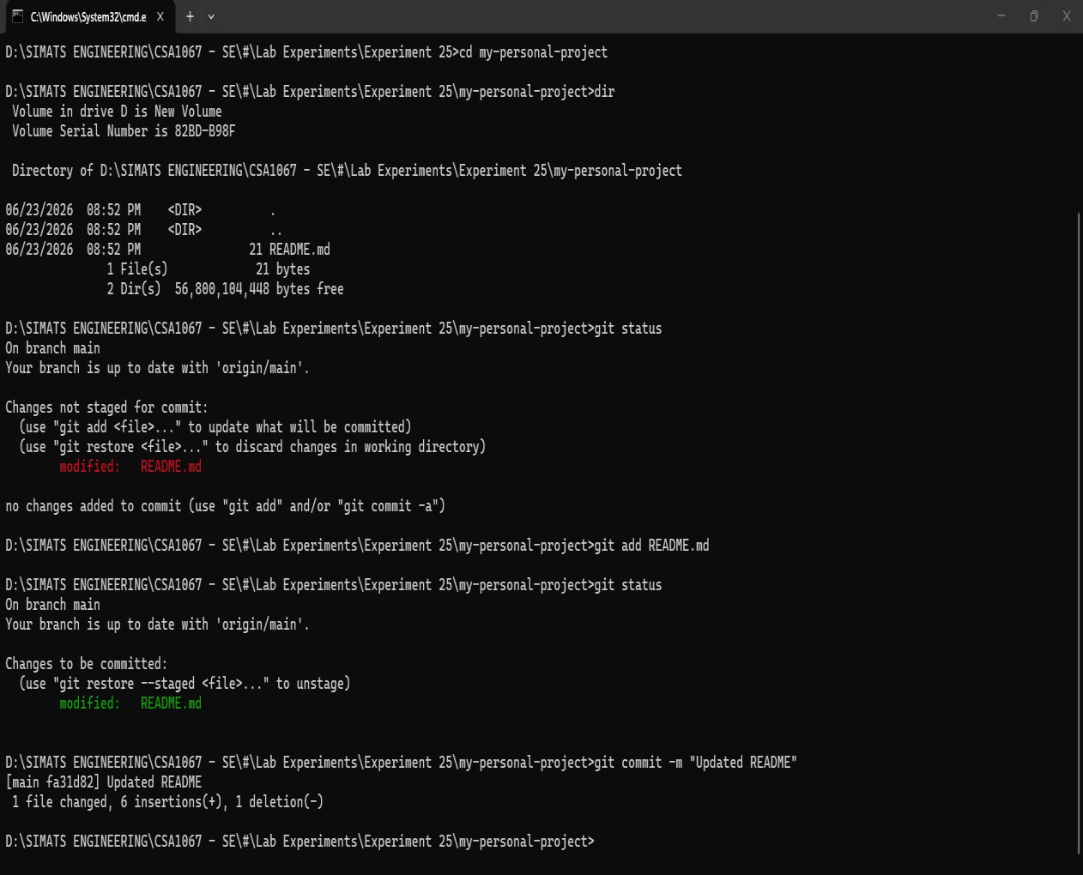

Result
Successfully created a GitHub repository, cloned it locally, updated the README file, and pushed the changes to GitHub.

Aim
To clone an existing GitHub repository and modify a file locally.

README.md modified successfully.

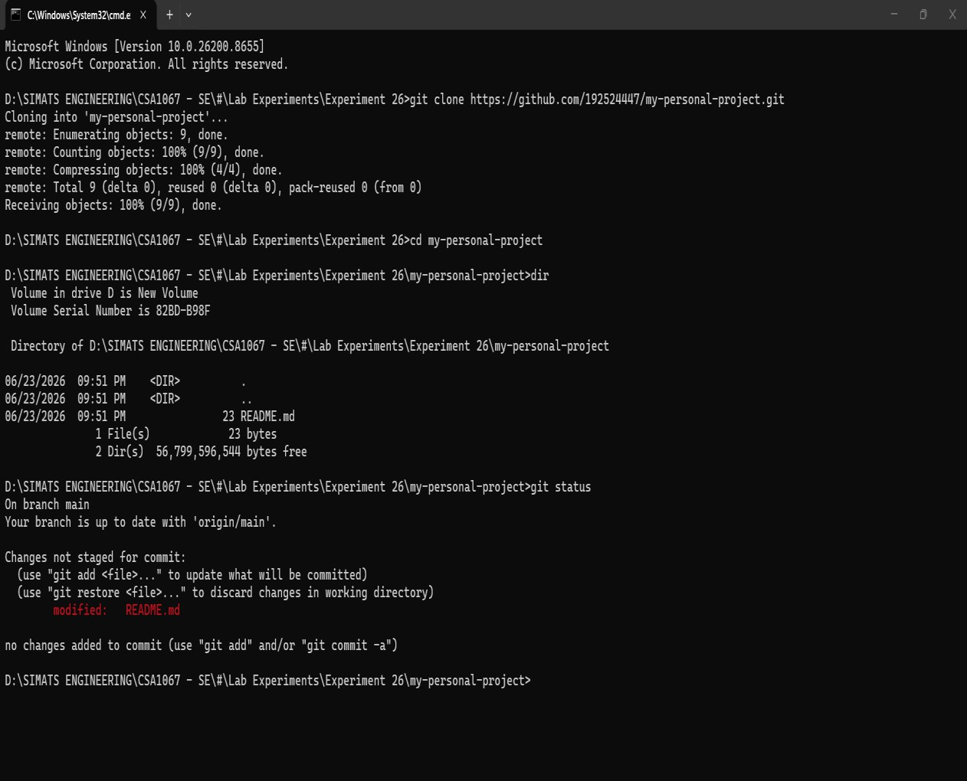

Result
Successfully cloned the GitHub repository and made a small change to a project file.

Aim
To commit changes made to a cloned repository locally and push them to GitHub using Git.

Changes committed and pushed to GitHub.

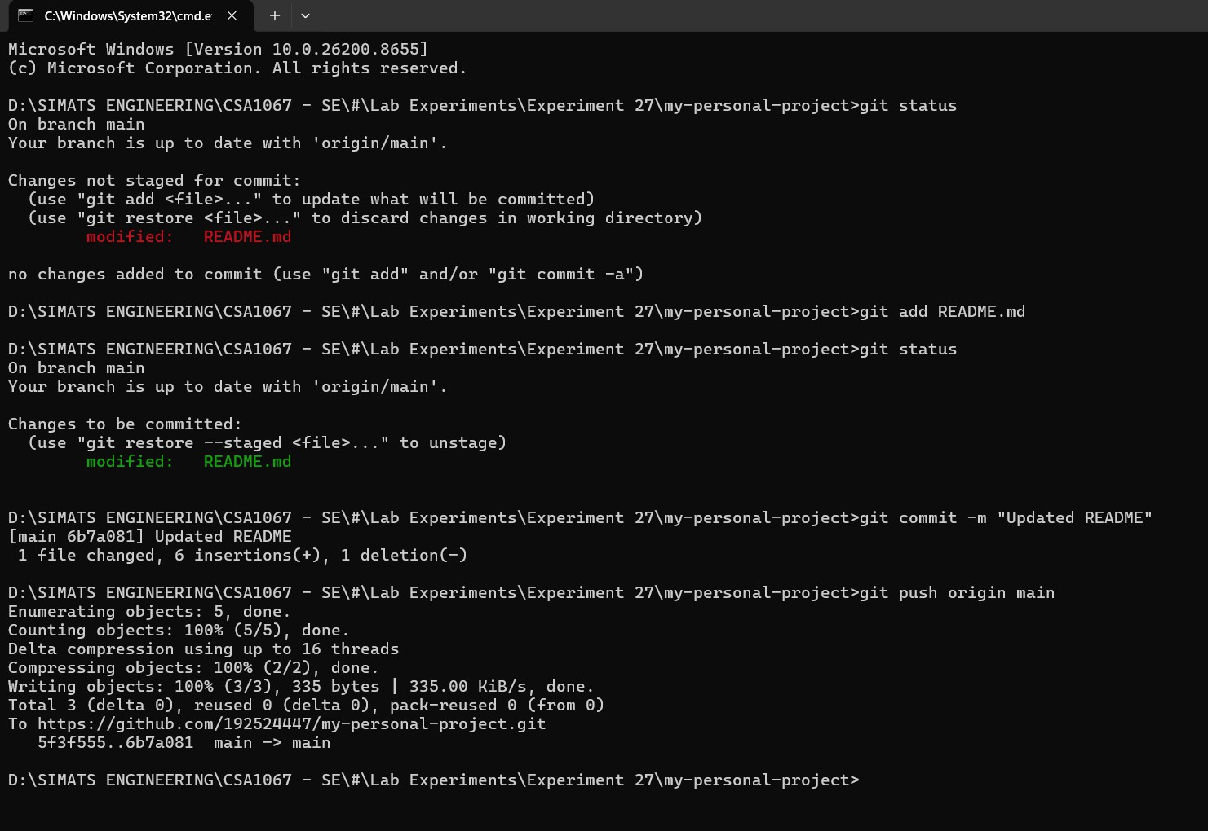

Result
Changes were successfully committed locally and pushed to GitHub.

Aim
To update the local repository with the latest changes made by a collaborator on GitHub.

Latest changes pulled successfully.

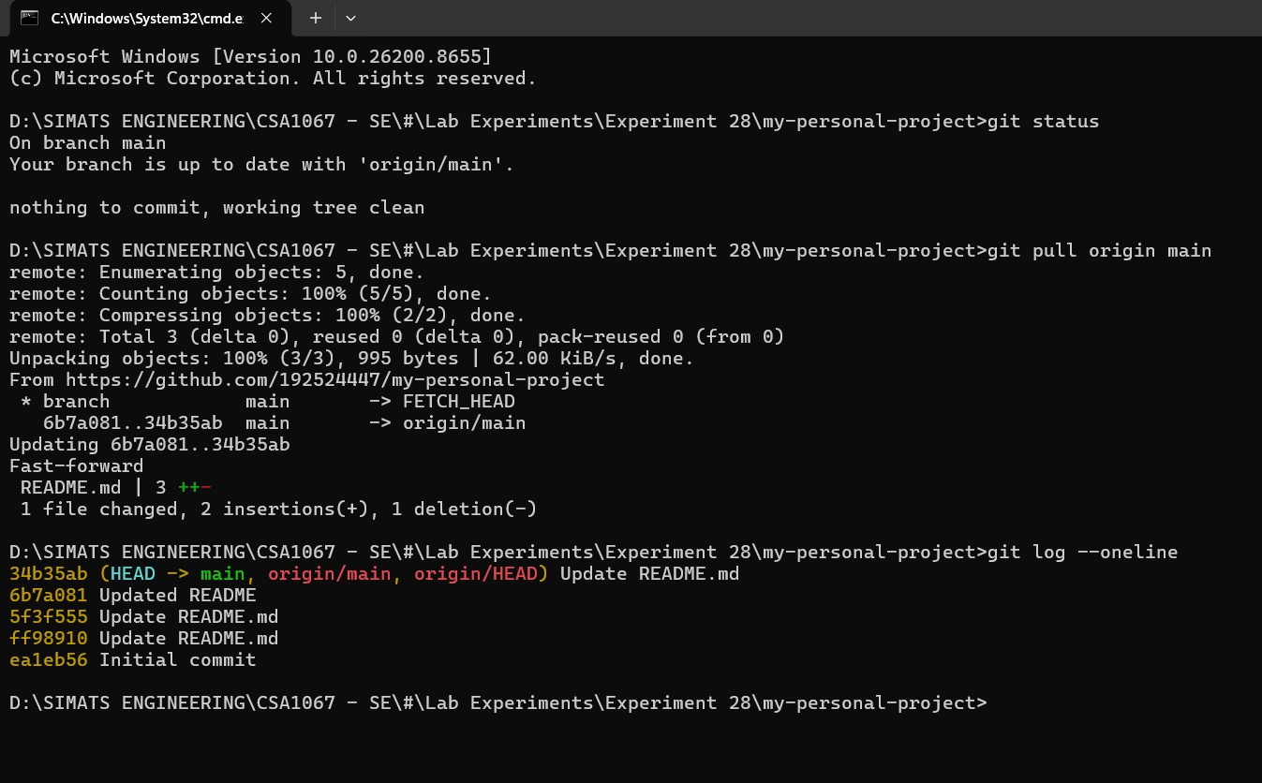

Result
Latest collaborator changes were successfully pulled from GitHub and updated in the local repository.

To create a feature-login branch, implement a simple login function, and merge it into the main branch using a Pull Request.

Login feature merged successfully.

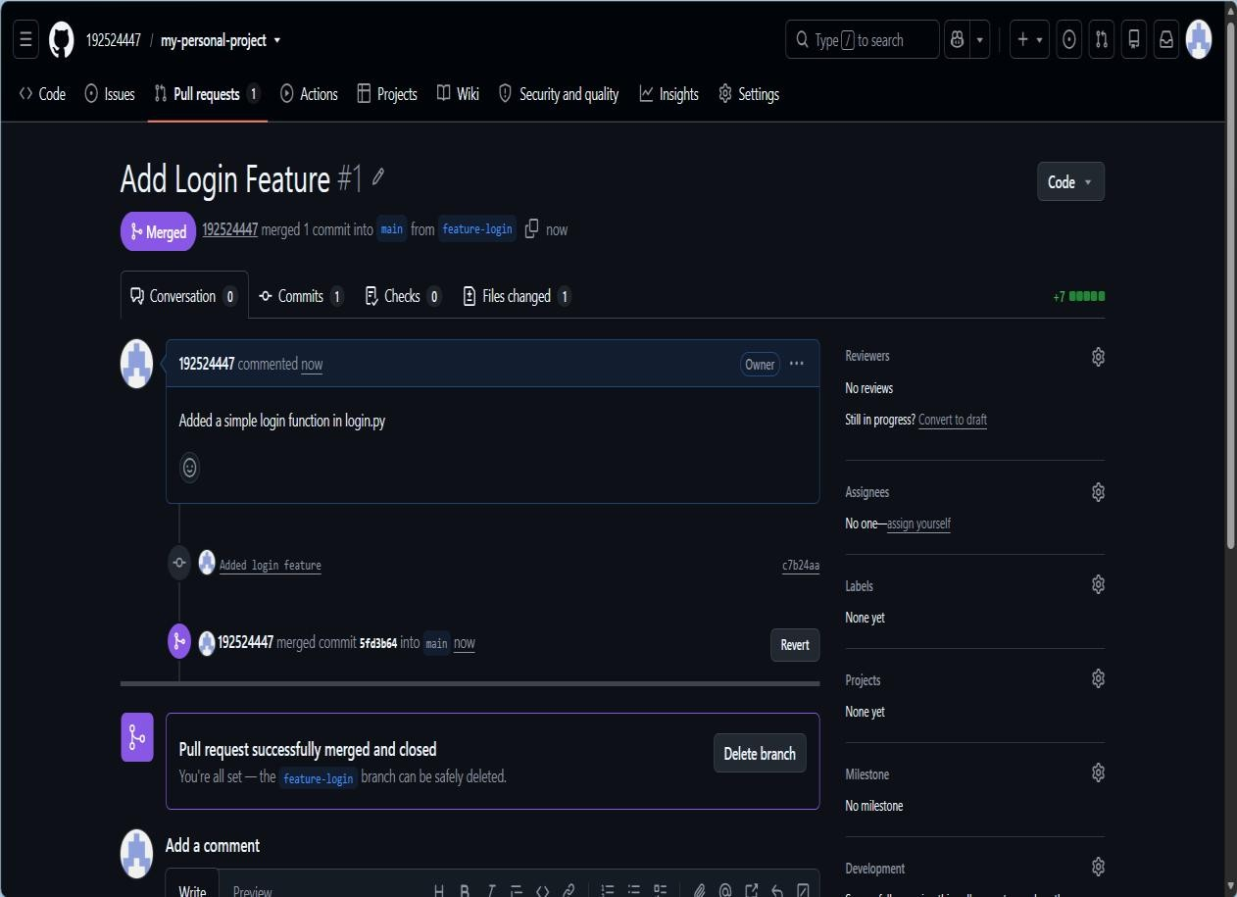

Result
The feature-login branch was created, the login function was added, and the changes were successfully merged into main.

To fork a repository, create a feature branch, implement changes, and submit a Pull Request to the original repository.

Pull request created successfully with no conflicts.

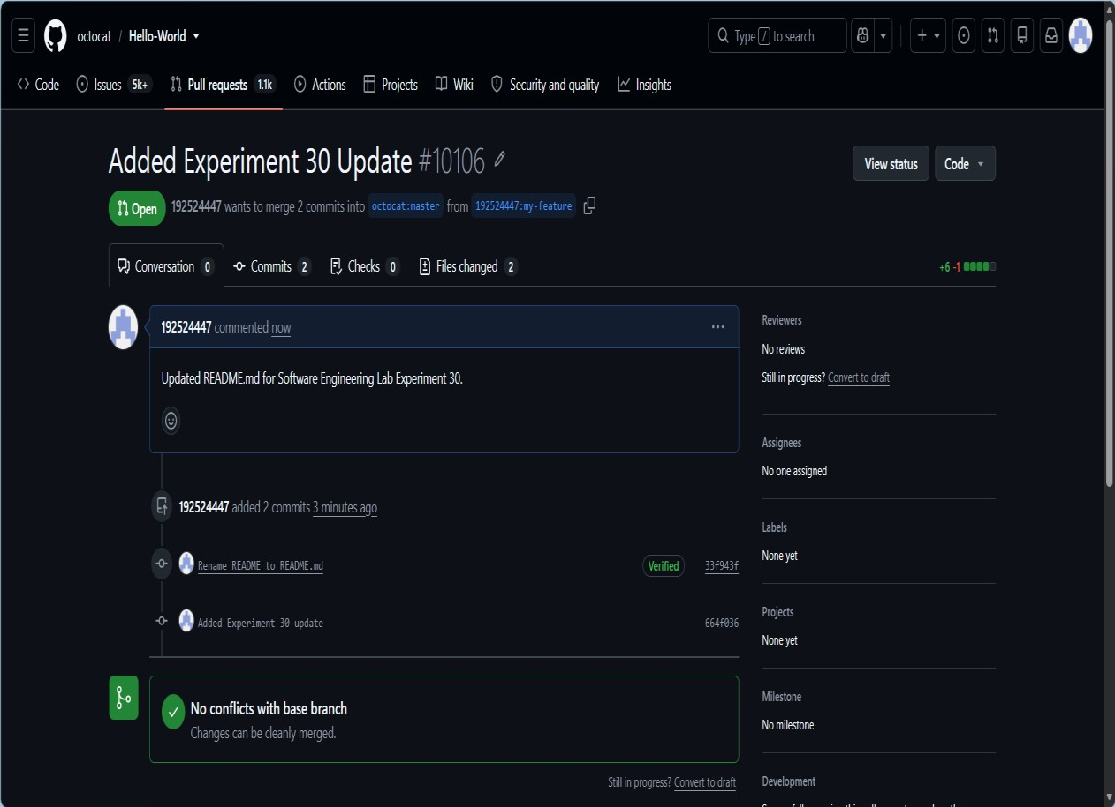

Result
Successfully forked the repository, created a feature branch, implemented changes, pushed them to the fork, and submitted a Pull Request to the original repository.

Google Sheet or Excel
EXP: 11-MoSCoW Prioritization of Library Management System Requirements Aim:
To categorize the Library Management System requirements using the MoSCoW method based on user impact, feasibility, time, budget, and resources.

MoSCoW categorization of library system requirements in Excel.
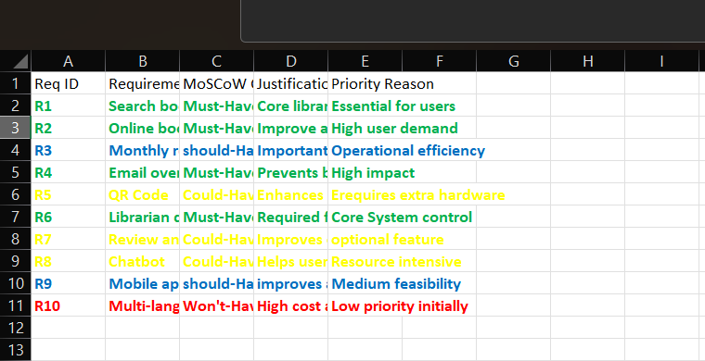

Result:
All requirements were successfully classified as Must-Have, Should-Have, Could-Have, or Won’t-Have, with suitable justifications.

